PHILIP MURUNGA SISA

UNIVERSITY OF NAIROBI
[Type the company address]
[Type the phone number]
[Type the fax number]
[Pick the date]
SISA
[Type the abstract of the document here. The abstract is typically a short summary of the contents of the document. Type the abstract of the document here. The abstract is typically a short summary of the contents of the document.]

CHAPTER 1
INTRODUCTION
1.1 Scope
To study the Global Positioning System and Software Defined Radio (SDR) receiver. To design and demonstrate the SDR.
1.2 Background (GPS)
Global Positioning System (GPS) (the full description is : Navigation System with Timing And Ranging Positioning System NAVSTAR-GPS), is a Global Navigation Satellite System(GNSS) that was developed by the United State Department of Defense; and be used for both military and civilian purpose. The system is made up of three segments namely; satellite, control and receiver segment. There are 30 GPS satellites in constellation by the year 2012, the oldest one was launched in the year 1989. These are the one in operation now. Another 22 have been launched since the program started in 1978, but are no longer working. [2]
The first 11 satellite, known as Group I and designed by Rockwell International , were launched into orbit between 22 February of 1978 and 1985 from vandenburg Air Force Base in California each of this satellite contained one Cesium and Rubidium atomic clocks and could provide navigation and standard positioning information. Continuous contact with the ground control segment was required for their operation. They were designed to last for five years, but most lasted much longer.
The next group of 9 satellites is called Group II and was also designed by Rockwell. These were the first to provide precision positioning information for military use and to be able to operate for 14 days without contact with the Control Segment. Group II satellites contained four clocks two Cesium and two Rubidium and were launched between February 1989 and October 1990 from Cape Canaveral Air Force Station in Florida. They were designed to last 7.3 years and two currently remain in operation. The Group IIA satellites were next group to be designed by Rockwell and numbered 19.
They are similar to the Group II satellites, except they have the ability to operate
180 days without contact with Control Segment. These were launched from Cape Canaveral between November 1990 and November 1997. All but three of these satellites are still in operation.
The most recent type, Group IIR, was designed by Lockheed Martin and each have three Rubidium clocks. They were designed to provide more accurate information through a combination of ranging techniques and communication between the satellites. They are also designed to last slightly longer (7.8 years) and to have improved independent controls. There are currently 12 such satellites in orbit the most recent launched in November 2004.
The satellites are launched via a Delta II rocket designed by Boeing. These are
expendable launch vehicles (ELVs), meaning they are intended for one use only.
Each of these ELVs consists of the following:
Stage I which contains fuel and oxygen tanks to supply the main engine during
its climb; Solid rocket booster motors to provide additional thrust during the first two minutes of flight.
Stage II which contains the fuel and oxidizer tanks that supply the engine needed to insert the ELV into orbit and the brains of the ELV, including its guidance system.
Stage III that has a solid rocket motor to provide any needed velocity change.
1.3 GPS in brief
Currently GPS satellite are orbiting at a height of 20,180 Kilometer with speed of 7000 kilometer per hour, the orbits of each satellite is inclined to the Equator at 55 degrees ensuring minimum of 4 satellite visibility at any point on globe.
The civil signal SPS (Standard Positioning Service) can be used freely by the general, while the military signal PPS (Precise Positioning Service) can only be used by authorized government agencies. Satellite transmitting code-division multiple access system (CDMA) signals on 1.57542 GHz for civilian ranging purpose with appropriate ground receivers.
1.4 Software defined Radio (SDR).
A GPS receiver is composed of radio frequency (RF) front end, acquisition stage, tracking stage and lastly the navigational co-ordinates display stage. SDR is implemented with only RF front end at hardware level, the other stages are realized at software level, the software is moved as close as possible to the antennae. The RF front end can be implemented by Field programmable Gate Array
(FPGA), application-specific integrated circuits (ASIC) and integrated circuits. The software level can be implemented by C, C++, matlab or any other object oriented programming language and Graphical programming approach such as Simulink embedded in MATLAB(matrix lab) software. SDR is a promising technology that facilitates development of multi-band. [2]
CHAPTER 2
REVIEW OF LITERATURE
2.1 Global Navigation Satellite Systems (GNSS)
2.1.1 Global Orbiting Navigation Satellite System (GLONASS)
GLONASS is the Russian implementation of a GNSS. Its development, both historically and functionally mirrors GPS. There is however, some difference in the signal structure of the two systems. Initiated as a military system, control of
GLONASS falls under the Russian Military of Defense. Broadcasting of the signal from the satellite is composed of more than one component in two distinct bands. AS a result of its potential benefit to the civilian community, a portion of the broadcast, which is the responsibility of the Russian Space Agency, has been designated for public use. The following description concentrates on the civilian component of GLONASS which is the focus of the software radio implementation.
The GLONASS space segment consists of 24 satellites operating in three orbital planes (eight satellites in each plane). Again, this configuration has been designed to provide at least four visible satellites at any location on the earth with high probability. Monitoring and maintenance (orbital corrections and data uploads) are handled by the GLONASS ground-based control segment. The GLONASS user segment consists of the base of receivers. [19]
The GLONASS signal of interest is described mathematically as follows;

Si(t) = $\sqrt{2P}$ *R(t)M(t)Di(t)cos(2π(fc+i*0.5625*${10}^{6}$)t+φ)

Where;
Si- GLONASS broadcast on the i frequency channel
i-indicates frequency channel
P-signal power
R-PRN code (511 kbps)
M- Meander sequence (100 bps)
Di- navigation data for the i channel (50 bps)
fc- 1602.0 MHz (GLONASS base frequency)
φ- Phase offset.
From this equation the major difference from the GPS signal structure are readily apparent one of the principle differences is that GLONASS uses the more common FDMA approach, assigning each satellite a unique frequency. Initially, there were 24 frequency channels, one for each orbital slot, designated for public use. The specific frequencies are determined from Equation 2.3 using an integer value for i between 1 and 24 which corresponds to the specific channel number. As a result of interference with the radio astronomy band (1610.6 to 1613.8 MHz), changes have been proposed and implemented in the frequency plan. Currently, frequency channels 16, 17, 18, 19, and 20 are not in use. In order to compensate for this change, satellites in antipodal positions are assigned the same frequency. The success of this implementation has led to two future frequency plan changes. In the 1998 to 2005 time-frame, GLONASS satellites will use frequency channels 0 through 12. Beyond the year 2005, GLONASS satellites will be assigned to frequency channels -7 through +6, which indicates the center of the GLONASS band will be shifted to the current base frequency of 1602.0 MHz.
Although GLONASS uses FDMA for multiple accesses, it also incorporates a PRN code for ranging purposes. The GLONASS PRN code has a chipping rate of 511 kbps and a period of 511 chips, or 1 ms. The PRN code is a maximal length sequence generated using a nine position shift register, sampling the output of the seventh digit. The generator polynomial for GLONASS
is given by:
G:$x^{9}$+ $x^{5}$ + 1
As a result of the FDMA implementation, every GLONASS satellite uses the same PRN code. The navigation data, Di(t), is generated at 50 bps and combined with a meander sequence, M(t), generated at 100 bps to form the navigation message. Generation of the PRN code, navigation data, and meander sequence is synchronized within the transmitted signal. As is the case with GPS, the GLONASS navigation data provides the user the additional parameters necessary to
Solve for position, velocity, and time. The GLONASS data consists of a 7500 bit super frame made up of five 300 bit frames. Each frame is further subdivided into 15 strings of 100 bits. Strings 1-4 are the same in each frame and provide the precise ephemeris and timing information for the broadcasting satellite. String 5 contains additional timing information. Strings 6-15 differ between frames and provide GLONASS almanac and support information. Each navigation string, which is of two second duration, is divided into two distinct parts. The first 1.7 seconds
in any string is the navigation message while the last 0.3 seconds of each navigation string Consists of a 30 bit time mark. A shorten PRN sequence provides the 30 bit time mark which is given by:
Gm: 111110001101110101000010010110
Again, the exact format of the GLONASS data and the associated algorithms necessary to solve for position, velocity, and time are well documented. It is important to recognize that the critical navigation data is broadcast every 30 seconds. Therefore, as with GPS, a 30 second 'window' of GLONASS data will provide all the fundamental parameters necessary for position computation.

2.1.2 Galileo
Galileo is European, civil satellite navigation system which is being developed for global use. Galileo is designed to make the Europe independent of the USA's GPS and the Russian GLONASS. As a joint project of the EU and the European Space Agency (ESA), Galileo will be compatible and interoperable with GPS, but will guarantee independent and reliable usability. [21]
The Nederlands Economic Institute (NEI) has calculated that if GPS were to fail for just 2 days, Europe would suffer a loss of 220 million Euros in the transport sector alone.
Galileo will perform better in finding location within 1 meter compared to five meters with NAVSTAR- GPS. It also offer greater penetration in urban areas and the coverage will improve in northern Europe and other high latitude areas.
27 Galileo satellites are in orbits, marking the very first step to full operability of Europe’s new global navigation satellite system, under a partnership between ESA and the European Commission (EC); Geometry of 3 orbital planes inclined at 56 degree to equator meaning each orbit has 9 satellite with spare each; constellation at 23,222 Kilometers; Orbital Period of 14.04 hours coverage is global transmitted satellite signal can be of 3 types namely:-
E1- 1.57542 GHz
E6-1.27875 GHz
E5-1.191795 GHz [21]
E1 (channel A) is a restricted access signal. It’s ranging codes and navigation data are encrypted. The data signal is E1-B and the data-free signal is E1-C. A data-free signal is also called a pilot signal. It is made of a ranging code only, not modulated by a navigation data stream. The E1 signal has a 4092 code length with a 1:023MHz chipping rate giving it a repetition rate of 4ms; on the pilot signal a secondary code of length 25 chips extends the repetition interval to 100ms.
Under some circumstances it may be difficult to separate the wanted signal from
the unwanted ones and the unwanted one is often a cross correlation from another satellite as the inherent CDMA isolation of the codes is only around 21 dB. The cross-correlation problem is solved by using very long codes. However, longer
codes also delay the acquisition process. To search the very long code lengths
proposed for the new signals would be impractical, so the codes have been
designed with escape routes. The most common one is called a tiered code. This
means it is built in layers so that when you have a strong signal you can acquire
on a simple layer, with less time-domain possibilities, only switching to the
Full-length code when required. The minimum bandwidth is generally twice the chipping rate for simple codes, while for BOC codes it is twice the sum of chipping rate and offset code rate. Thus, the minimum practical bandwidth for the Galileo E1 is 8MHz. The signal is the product of carrier, spreading code, BOC, and data. Traditionally, the RF hardware removes the carrier, the correlators remove the BOC (1,1) code, leaving the data and the residual Doppler to be removed/measured by a processor. With the BOC (1,1) codes, the BOC component should have been considered part of the spreading code for tracking and positioning; but it is equally viable to consider it part of the carrier during the acquisition phase, and remove it prior to the empirical correlation of acquisition.
The ACF of a BOC (1,1) code has three peaks, not just one, so care must be taken
to ensure that the correct one has been found. The transmitted bandwidth is 24 *1.023MHz =24.554MHz. The minimum received power for the E1 signal is -157 dBW for elevation angles between 10 degrees and 90 degrees. The chip length of the ranging code is; 1/1.023 = 997.5nanoseconds. The secondary code modulates 25 specific repetitions of the primary code. For each subcarrier all satellites transmit the same secondary code: the octal sequence 34012662. The resulting code length is 4092 _25. It is called a tiered code. Let the primary code generator work with chip rate RP . The secondary code generator has chip rate RS DRP =NP, where NP is the length in chips of the primary code. In all signal modulations the logical levels 1 and 0 are defined as signal level -1 and 1 (polar non-return-to-zero representation).Now we have information for defining the binary signal components for channels B and C. However, information on channel A is not available. The signal component for channel B results from the modulo-2 addition of the navigation data stream dE1-B, the PRN code sequence cE1􀀀B, and the B
Sub-carrier scE1-B. The final component is called eB. Likewise, the C channel results from the modulo-2 addition of the C channel PRN code sequence cE1-B with the C channel subcarrier scE1-C. The component is eC. The binary signal components are as follows:

2.1.2.1 Channel signals of E1 [21]

eA(t ) not available,
$eB(t)$= $\sum_{i=-∞}^{∞}{(cE1-B,\left(imod4092\right)dE1-B,\left(imod4\right)rectTc,E1B\left(t- iTc,E1-B\right)*sign\left(\sin\left(2πRc,E1-B\left(t\right)\right)\right))}$
$eC(t)$ = $\sum_{i=-∞}^{∞}{(cE1-C,\left(imod4092\right)rectTc,E1-C\left(t-iTc,E1-C\right)* sign\left(\sin\left(2πRc,E1-Bt\right)\right))}$
The three channel signals eA(t), eB(t), and eC(t) of the E1 signal are multiplexed using CASM which is a multichannel modulation scheme also known as tricode hexaphase modulation (or interplex modulation). [21]
CASM is used to ensure that the signal transmitted from the satellite has a constant power envelope, i.e., the total transmitted power does not vary over time. Thus, the transmitted information is not contained in the signal amplitude and the transmitted signal amplitude becomes less critical. This is a very desirable property of the signal since it allows the use of efficient “class C”-like power amplifiers.
The E1 data and pilot signals are modulated onto the carrier in-phase component
while the E1-A signal is modulated onto the quadrature component. The
combined signal is
$$S\left(t\right)=\left(αeB\left(t\right)- αeC\left(t\right)\right)\cos\left(2πf1t\right)- \left(βeA\left(t\right)+ γeA\left(t\right)eB\left(t\right)eC\left(t\right)\right)sin⁡(2πf1t)$$
In this expression γ, α and β and are amplification factors that determine the
Distribution of useful power among the channels A, B, and C. We assume B and
C has equal power.

$eE1-A$

CASM

s $dE1-B$s
$cE1-B$ $eE1-B$
sE1

$cE1-C$ $eE1-C$
$scE1-C$
Fifure 2-1 Gallileo signal modulation scheme [21]
The Galileo signals and the planned modernized GPS signals inherit improved
Performance compared to the existing GPS signals. One of the improvements is
the introduction of the binary offset carrier (BOC) modulation. BOC modulations offer two independent design parameters subcarrier frequency fs in MHz, and spreading code rate fc in Mchip/s. These two parameters provide freedom to concentrate signal power within specific parts of the allocated band to reduce interference with the reception of other signals.
Furthermore, the redundancy in the upper and lower sidebands of BOC modulations offers practical advantages in receiver processing for signal
Acquisition, code tracking, carrier tracking, and data demodulation.
Most Galileo signals come in pairs: a data signal and a data-free signal. They are
aligned in phase and consequently have the same Doppler frequency.
A BOC(m,n)signal is created by modulating a sine wave carrier with the product
of a PRN spreading code and a square wave subcarrier having each binary _1
values. The parameter m stands for the ratio between the subcarrier frequency and the reference frequency f0=1.023MHz, and n stands for the ratio between the code rate and f0. Thus, BOC(10,5) means a 10.23MHz subcarrier frequency and a 5.115MHz code rate.
The aim of the subcarrier modulation is to split the classical BPSK spectrum in
Two symmetrical components with no remaining power on the carrier frequency
The product is a symmetric split spectrum with two main lobes shifted from the
Carrier frequency by the amount equal to the subcarrier frequency, confer a
Subsequent figure. We concentrate on BOC(m,n)=BOC(1,1)as this is likely to
be used by the E1 signal transmitted by Galileo.
The ACF of BOC signals has a profile with more peaks that may be tracked. For
BOC signals it is important to make sure the channel is tracking the main peak of
the correlation pattern. So additional correlators are needed for measuring the
correlation profile at half a subcarrier phase from prompt correlator at either side.
If one of the output values of these so-called very early and very late correlators
is higher than the punctual correlation, the channel is tracking a side peak and
Corrective action is taken.

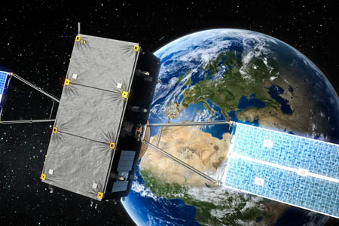

Figure 2-0 Galileo satellite in space
2.1.3 Chinese Compass System (BeiDou 2)
Compass Navigation Satellite System is the second generation satellite navigation system capable of providing continuous real time passive 3D geo-spatial position and speed measurement the system has total of 35 satellite geometry of 3 plane for each 9 satellite and one spare in each plane, orbiting at 21,500 Kilometre from sea level, orbital period of 14.04 hours, not yet fully globally covering; still
under construction till 2017.

2.1.3.1 BeiDou 2 future plan
The new system will be a constellation of 35 satellites, which include 5 geostationary orbit (GEO) satellites, 30 medium Earth orbit (MEO) satellites that will offer complete coverage of the globe. There will be two levels of service provided; free service for those in China, and licensed service for the military.
Three satellites for Beidou 2 have been launched in early 2007, in early 2009 and in early 2010. In the next few years, China plans to continue setting up the system for global operation from 2017 with 30 satellites. Regional operation within Asia Pacific would be completed with more than 10 satellites in late 2012.

2.1.4 Global Positioning System (GPS)
2.1.4.1 What it is
Global Positioning System (GPS) (the full description is : Navigation System with Timing And Ranging Positioning System NAVSTAR-GPS), is a Global Navigation Satellite System(GNSS) that was developed by the United State Department of Defense; and be used for both military and civilian purpose. [7]
During the development of the GPS system, particular emphasis was placed on the following three aspects:
- It had to provide users with the capability of determining position, speed and
Time, whether in motion or at rest.
2. It had to have a continuous, global, 3-dimensional positioning capability with
a high degree of accuracy, irrespective of the weather.
- It had to offer potential for civilian use.

      - Description of the entire system
The GPS comprises three segments namely:-
- The space segment.
- The control segment.
- The user segment (all military and civil users).
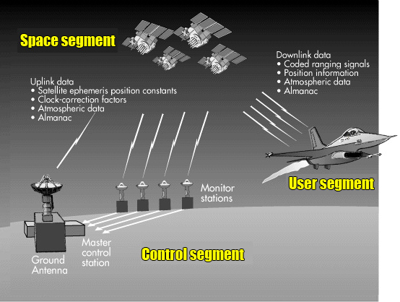
Figure 2-1 GPS segments

2.1.4.2.1 Space segment
The space segment currently consist of 32 operational satellite orbiting the Earth
on 6 different orbital planes. They orbit 20,180 Kilometers above Earth surface and are inclined at 55 degree to the equator. One satellite completes its orbit in about 12 hours. Due to the rotation of the Earth, a satellite will be at its initial starting position after approx. 24 hours (23_ hours_ 57 minute to be precise). [7]
Satellite signals can be received anywhere within a satellite’s effective range.
The distribution of the 32 satellites at any given time can be seen It is due to this ingenious pattern Of distribution and to the great height at which they orbit that communication with at least 4 satellites is ensured at all times anywhere in the world. All 28 satellites transmit time signals and data synchronized by on board atomic clocks at the same frequency (1575.42 MHz). The minimum signal strength received on Earth is approximately 158dBW -160dBW. Accordance with the specification, the maximum strength is approximately 153dBW.
The minimum amount of power received must not fall below160dBW (-130dBm). In order to ensure this level is maintained, the satellite L1carrier transmission power, modulated with the course acquisition code (C/A), must be 21.9W.
The following information is transmitted by the satellite at the rate of 50 bits per second;
- Satellite time and synchronization signals.
- Precise orbit data (ephemeris).
- Time correction information to determine the exact satellite time.
- Approximately orbital data for all satellites (almanac).
- Correction signals to calculate signal transit time.
- Data on the ionosphere.
- Information on satellite health. [7]
The time required to transmit all this information is 12.5 minutes. By using the navigation message the receiver is Able to determine the transmission time of each satellite signal and the exact position of the satellite at the time of transmission. Each of the 28 satellites transmits a unique signature assigned to it. This signature consists of an apparent Random sequence (Pseudo Random Noise Code, PRN) of 1023 zeros and ones.
The atomic clocks on board a satellite have a greatest stability the basic frequency of10.23MHz is derived in a satellite from the resonant frequency of one of the four atomic clocks. In turn, the carrier frequency, data frequency, the timing for the generation of pseudo random noise (PRN), and the C/A code (course acquisition code), are derived from this basic frequency. As all 32 satellites transmit on 1575.42 MHz, a process known as CDMA Multiplex (Code Division Multiple Access) is used. The data is transmitted based on DSSS modulation (Direct Sequence Spread Spectrum Modulation) The C/A code .generator has a frequency of 1023 MHz and a period of 1,023 chips, which corresponds to a millisecond. The
C/A code used, which is the same as a gold code, and therefore exhibits good correlation properties, Is generated by a feedback shift register.
The C/A code plays an important part in this process. As all satellites transmit on the same frequency (1575.42_MHz), the C/A code contains the identification and information generated by each individual satellite. The C/A code is an apparent random sequence of 1023 bits known as pseudo random noise. This signature, which lasts a millisecond and is unique to each satellite, is constantly repeated. A satellite is always identified, therefore, by its corresponding C/A code.

2.1.4.2.2 Control Segment
The control segment (Operational Control System OCS) consists of a Master Control Station located in the state of Colorado, five monitor stations equipped with atomic clocks that are spread around the globe in the vicinity of the equator, and three ground control stations that transmit information to the satellites. The most important tasks of the control segment are:
- Observing the movement of satellite and computing orbital data (ephemeris).
- Monitoring satellite clock and predicting their behavior.
- Synchronizing on board satellite time.
- Relaying precise orbital data received from the satellite in communication.
- Relaying the approximate orbital data of all satellites (almanac).
- Relaying further information, including satellite health, clock errors. [7]
The control segment also oversees the artificial distortion of signals to degrade the system’s positional accuracy for civil use. System accuracy had been intentionally degraded up until May 2000 for political and tactical reasons by the United State Department of Defense, the satellite operators. It was shut-down in May 2000, but it can be started up again, if necessary, either on a global or regional basis.

TYPE OF CONTROL | LOCATION
Master control station | Colorado Springs
Master control station (back up) | Gaithersburg, MD
Monitor station | Colorado Springs
Remote monitor station | Cape Canaveral, FL
Remote monitor station | Diego Garcia
Remote monitor station | Kwajalein
Remote monitor station | Hawaii
Remote monitor station | Ascension Islands
Ground antenna | Cape Canaveral, FL
Ground antenna | Ascension Islands
Ground antenna | Diego Garcia
Ground antenna | Kwajalein

Table 2-1 Locations of Operational Control Segment on globe.

        - User Segment
As the transmitted signals from the satellite travel at the speed of light, their transit time depends on the distance between the satellites and the user. Four or more different signals are generated in the receiver having the same structure as those received from the four or more satellites.
The receiver can be a conventional or software defined type of a receiver. By synchronizing the signals generated in the receiver with those from the satellites, the four satellite signal time shifts Δt are measured as a timing mark. The measured time shifts Δt of all 4 satellite signals are used to determine signal transit time.
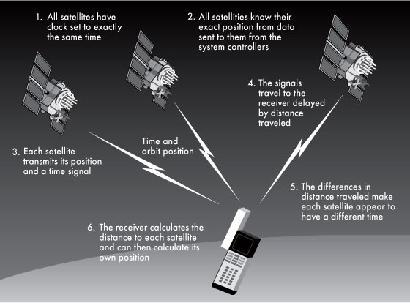
Figure 2-2 GPS user and space segment

      - The GPS Navigation Massage
The navigation message is a continuous stream of data transmitted at 50 bits per second. Each satellite relays the following information to Earth:
- System time and clock correction values.
- Its own high accurate orbital data (ephemeris).
- Approximate orbital data for all other satellites (almanac).
- System heath.
The navigation message is needed to calculate the current position of the satellites and to determine signal transit times. The data stream is modulated to the high frequency carrier wave of each individual satellite. Data is transmitted in logically grouped units known as frames or pages. Each frame is 1500 bits long and takes 30 seconds to transmit. The frames are divided into 5 sub frames. Each sub frame is 300 bits long. In order to transmit a complete almanac, 25 different frames are required (called pages).Transmission time for the entire almanac is therefore 12.5 minutes. A GPS receiver must have collected the complete almanac at least once to be capable of functioning (for instant for its primary initialization).
A frame is 1500 bits long and takes 30 seconds to transmit. The 1500 bits are divided into five sub frames each of 300 bit. Each sub frame is in turn divided into 10 words each containing 30 bits. Each sub frame begins with a telemetry word and a handover word. A complete navigation Message consists of 25 frames (pages). The structure of the navigation message is illustrated in diagrammatic format in next figure.

Satellite clock  & health data | Ephemeris | Ephemeris | Partial almanac  other data | Almanac

Sub frame 1 |sub- frame 2 |sub- frame 3 |sub-frame 4 |sub frame 5

Figure 2-3 Navigation massage components

A frame is divided into five sub frames, each sub frame transmitting different information.
- Sub frame 1 contains the time values of the transmitting satellite, including the parameters for correcting signal transit delay and on board clock time, as well as information on satellite health and an estimation of the positional accuracy of the satellite. Sub frame 1 also transmits the so called 10-bit week number (arrange of values from 0 to 1023 can be represented by 10 bits). GPS time began on Sunday, 6th January 1980 at 00:00:00 hours. Every 1024 weeks the week number restarts at 0.
- Sub frames 2 and 3 contain the ephemeris data of the transmitting satellite; this data provides extremely accurate information on the satellite’s orbit.
- Sub frame 4 contains the almanac data on satellite numbers 25 to 32(each sub frame can transmit. Data from one satellite only), the difference between GPS and Universal Time Co-ordinate ( UTC ) time and information regarding any measurement errors caused by the ionosphere
- Sub frame 5 contains the almanac data on satellite numbers 1 to 24 (each sub frame can transmit data from one satellite only). All 25 pages are transmitted together with information on the health of satellite numbers 1 to 24. [7]
The first word of every single frame, the telemetry word (TLM), contains a preamble sequence 8 bits in length (10001011) used for synchronization purposes, followed by 16 bits reserved for authorized users.
As with all words, the final 6 bits of the telemetry word are parity bits.
The handover word (HOW) immediately follows the telemetry word in each sub frame.
The handover word is 17bits in length (a range of values from 0 to 131071 can be represented using 17 bits) and contains within its structure the start time for the next sub frame, which is transmitted as time of the week (TOW). The TOW count begins with the value 0 at the beginning of the GPS week (transition period from Saturday 23:59:59 hours to Sunday 00:00:00hours) and is increased by a value of 1 every 6 seconds. As there are 604,800 seconds in a week, the count runs from 0 to 100,799, before returning to 0. A marker is introduced into the data stream every6 seconds and the HOW transmitted, in order to allow synchronization with the P code. Bit numbers 20 to 22 are used in the handover word to identify the sub frame just transmitted.
A complete navigation message requires 25 pages and lasts 12.5 minutes. A page or a frame is divided into five Sub frames.
In the case of sub frames 1 to 3, the information content is the same for all 25 pages. This means that a receiver has the complete clock values and ephemeris data from the transmitting satellite every30 seconds.
The sole difference in the case of sub frames 4 and 5 is how the information transmitted is organized.
In the case of sub frame 4, pages 2, 3, 4, 5, 7, 8, 9and 10 relay the almanac data on satellite numbers 25 to 32. In each case, the almanac data for one satellite only is transferred per page.
Page 18 transmits the values for correction measurements as a result of ionosphere scintillation, as well as the difference between UTC and GPS time.
Page 25 contains information on the configuration of all 32 satellites (block affiliation) and the health of satellite numbers 25 to 32.
In the case of sub frame 5, pages 1 to 24 relay the almanac data on satellite numbers 1 to 24. In each case, the almanac data for one satellite only is transferred per page. Page 25 transfers information on the health of satellite numbers 1 to 24 and the original almanac time.

      - Calculating position
The principle of measuring signal transit time (evaluation of pseudo-range)
In order for a GPS receiver to determine its position, it has to receive time signals from four different satellites (satellite 1 satellite 4), to enable it to calculate signal transit time Δt1….Δt4.
Calculations are effected in a Cartesian, three dimensional co-ordinate system with a geocentric origin. The range of the user from the four satellites R1, R2, R 3 and R 4 can be determined with the help of signal
Transit times Δt1 Δt 2, Δt3 and Δt 4 between the four satellites and the user. As the locations X Sat, Y Sat and Z sat of the four satellites are known, the user co-ordinates can be calculated.
Due to the atomic clocks on board the satellites, the time at which the satellite signal is transmitted is known Very precisely. All satellite clocks are adjusted or synchronized with each another and universal time co-ordinated.
In contrast, the receiver clock is not synchronized to UTC and is therefore slow or fast by Δto. The sign Δto is Positive when the user clock is fast. The resultant time error Δt0 causes inaccuracies in the measurement of signal transit time and the distance R. As a result, an incorrect distance is measured that is known as pseudo distance or pseudo-range PSR.

Satellite 2

Satellite 3

Satellite 1 Δt 2 Δt 3

Δt 1 Satellite 4
Planet-Earth Δt 4


Figure 2-4

$$Δtmeasured=Δt+Δto$$
PSR = Δt measured.c =(Δt+Δto).c
PSR = R + Δto.c
[7]

Where c- speed of light.
Δt- signal transit time from the satellite to user.
Δto- difference between the satellite clock and clock.
PSR- Pseudo – range.
R- true range of the satellite from the user.
The distance R from the satellite to the user can be calculated in a Cartesian system as follows.

R = $\sqrt{{\left(Xsat-Xuser\right)}^{2}+{\left(Ysat-Yuser\right)}^{2}+{\left(Zsat-Zuser\right)}^{2}}$ (2-1)

In order to determine the four unknown variable (Δto, X, Y, Z sat ) four independent equations of the following form are necessary.
Valid for the four satellite (i = 1…4)

PSR_i=$\sqrt{{\left(Xsat_i-Xuser\right)}^{2}+{\left(Ysat_i-Yuser\right)}^{2}+{\left(Zsat_i-Zuser\right)}^{2}}$ + c. Δto
(2-2)
The four equations under 6a produce a non-linear set of equations. In order to solve the set, the root function is first linearized according to the Taylor model, the first part only being used next figure.

Generally (with ΔX = X – Xo) :
f(X) = f(Xo)+(f’/1!)Xo* ΔX+(f’’/2!). ΔX*Xo^2 + (f’’’/3!) ΔX*Xo^3 +……

simplified (1st part only):

f(X) = f(Xo) + f’(Xo)* ΔX

In order to linearize the four equations (6a), an arbitrarily estimated value x0 must therefore be incorporated in The vicinity of x.For the GPS system, this means that instead of calculating XAnw , YAnw and ZAnw directly, an estimated position XGes , YGes and ZGes is initially used.

f(X) f’(Xo)

f(x)……………………………………….. Function
.
f(xo).…….………..………….
. .
. .
. .
. .
. .
. .
. .
Xo X

For ΔX = X - Xo
[7]
Figure2-5: Linearization of root function
The estimated position includes an error produced by the variables ΔX, ΔY, and ΔZ explained later.
Xanw = Xges + ΔX
Yanw = Yges + ΔY
Zanw = Z ges + ΔZ
The distance Rges from the four satellites to the estimated can be calculated in a similar way to equation;
$Rges-i$ = $\sqrt{{\left(Xsat_i-Xges\right)}^{2}+{\left(Ysat_i-Yges\right)}^{2}+{\left(Zsat_i-Zges\right)}^{2}}$ (2-3)

Combining equations 2-1,2,3, next equation results

PSRi = Rges_i + (ΔX)*(Xges – Xsat_i)/Rges_i + ΔY*(Tges – Tsat_i)/Rges_i
+ ΔZ*(Zges – Zsat_i)/Rges_i + c* Δto (2-4)
With i increasing that is from satellite 1to 4 or even more, equation 2-4 can be solved in matrix form to find PSR for equivalent satellite.
In order to determine a position, the user (or receiver software) will either use the last measurement value, or Estimate a new position and calculate error components (Δx, Δy and Δz) down to zero by repeated iteration. This then gives:

Xanw = Xges
Yanw = Yges
Zanw = Zges

The calculated value of Δt0 corresponds to receiver time error and can be used to adjust the receiver clock.

CAUSE OF ERROR | ERROR
Satellite clock | 2.1 meters
Effects of the ionosphere | 4 meters
Ephemeris data | 2.1 meters
Effects of troposphere | 0.7 meter
Multipath | 1.4 meters
Total RMs value (unfiltered) | 5.3 meters
Total RMS value (filtered) | 5.1 meters
Vertical error | 9 meters
Horizontal error | 7.4 meters

Table 2-4 Table showing sources of errors

      - Data Format
In order to relay computed GPS variables such as position, velocity, course to a peripheral for instant personal computer, GPS modules have a serial interface (Transistor Transistor Logic (TTL) or RS-232 level).
The most important elements of receiver information are broadcast via this interface in a special data format. This format is standardized by the National Marine Electronics Association (NMEA) to ensure that data exchange takes place without any problems.
Nowadays, data is relayed according to the NMEA-0183 specification. NMEA has specified data sets for various applications for instant Global Navigation Satellite System, GPS, Loran, Omega, and Transit and also for various
Manufacturers. The following seven data sets are widely used with GPS modules to relay GPS information;
- GGA (GPS Fix Data, fixed data for the Global Positioning System)
- GLL (Geographic Position – Latitude/Longitude )
- GSA (GNSS DOP and Active Satellite, degradation of accuracy and number of active satellite in the Global satellite Navigation System)
- GSV (GNSS Satellite in View, Satellite in view in the global Satellite Navigation System).
- RMC (Recommended Minimum Specific GNSS Data)
- VTG (course over Ground and Ground Speed, horizontal course and horizontal velocity).
- ZDA (Time and Date). [7]

In the case of NMEA, the rate at which data is transmitted is 4800 Baud using printable 8-bit ASCII characters.
Transmission begins with a start bit (logical zero), followed by eight data bits and a stop bit (logical one) added at the end. No parity bits are used.
Each GPS data set is formed in the same way and has the following structure:
$GPDTS, Inf_1, Inf_2,_Inf_3,Inf_4,Inf_5,Inf_6,Inf_n*CS<CR><LF>
The function of the individual character or character set is explained in next table

Field | Description
$ | Start of the data set
GP | Information originating from a GPS appliance
DTS | Data set identifier
Inf_ bis Inf_n | Information with number 1…n(for instant 174.4 for couse data)
, | Comma used to separate different items of information
* | Asteric used as a separator for the checksum
CS | Checksum (control word) for checking the entire data set
<CR><LF> | End of the data set: carriage return (<CR>) and line feed,(<LF>)

The maximum number of characters used must not exceed 79. For the purposes of determining this number, the start sign $ and end sign <CR> <LF> are not counted.

An example of a GGA data set:
$GPGGA,130305.0,4717.115,N,00833.912,E,1,08,0.94,00499,M,047,M,,*58<CR><LF>
The function of the individual character or character set is explained in next table

Field | Description
$ | Start of the data set
GP | Information
GGA | Data set identifier
130305.0 | UTC positional time :13h 03min 05.0 sec
4717.115 | Latitude 47 degrees 17. 115min
N | Notherly latitude (N = north, S= south)
00833.912 | Latitude 8 degree 33. 912
E | Easterly longitude (E = east W = west)
1 | GPS quality detail (0 = no GPS, 1 = GPS, 2=DGPS
08 | Number of satellite used in calculation
0.94 | Horizontal dilution of precision
0049 | Antenna height data (geoid height)
M | Unit of height
047 | Height differential between an ellipsoid and geoid
M | Unit of differential
,, | Age of the DGPS data (in this case no DGPS is used)
58 | Checksum for verifying the data set
0000 | Identification of the DDGPS reference
* | Separator
<CR><LF> | End of the data set

      - GPS receivers
GPs receivers can be realized by both hand-held and software defined approach.
2.0.4.6.1 Hand-held receiver [7]
It is composed of Radio Frequency (RF) front end, correlators, microcontroller and display to display location of the user.

antenna
Acquisition and tracking block ;has correlators and spread signal processor

mixer
If filter filterfilter

CASM

BPF

CASM

RF filter

CASM

LNA

CASM

amplifier
oscillator

CASM

Crystal | I |

CASM

clock

Display
Microcontroller
Data

Control
Keyboard

[1]
Figure 2-6 Blocks of a hand held GPS receiver

2.0.4.6.1 Sub-blocks of hand held receiver blocks
1. Antenna
Receives extremely weak satellite signal on a frequency of 1.57542 GHz.
2. Low Noise Amplifier ;( LNA)
Amplifies the signal by approximatelly15-21 db.IF filter the intermediate frequency is filtered by it using a bandwidth of 2-5 MHz.the images frequencies arising at the mixing stage are reduced to a permissible level.
3. Signal processor:
Up to 16 different satellite signals can be correlated and decoded at the same time.Correlation takes place by constant comparison with the C/A code.The HFstage and signal processor are simultaneously switched to synchronize with the signal.
4. The signal processor
has its own time base (Real Time Clock, RTC). All the data ascertained is roadcast (particularly signal transit time to the relevant Satellites determined by the correlator), and his is referred to as source data. The signal processor can be offset by the controller via the control line to function in various operating modes.
5. Microcontroller:
Using the source data, the controller calculates position, time, speed and course. it controls the signal processor and relays the calculated values to the display. Important information such as ephemeris, the most recent position are decoded and saved in RAM. The program and the calculation algorithms are saved in ROM.
6. Keyboard:
Using the keyboard, the user can select, which co-ordinate system he wishes to use and which
Parameters (for instant number of visible satellites) should be displayed.
7. Display:
The position calculated (longitude, latitude and height) must be made available to the user. This can either be displayed using a 7-segment display or shown on a screen using a projected map. The positions determined can be saved, whole routes being recorded.

2.1.4.6.2 Software defined GPS receiver
SDR defers from the hand held on in acquisition, tracking and Pseudo-range calculation stages which are implemented using software that is graphical programming or just writing the source code to be executed by the general purpose computer. The approach is to get the analogue to digital close to the antenna as possible.

Antenna
Personal Computer application
Peripheral Hardware level
Software level implementing
Acquisition, Tracking and pseudo range calculation stages. Good example Matlab/simulink

Analogue to digital converter
(ADC)

Radio Frequency
Front end

CASM

[23] Figure 2-7 SDR software block diagram.
2.1.4.6.2.1 Advantages of SDR
A software implementation of a GPS receiver is more desirable than a traditional hardware implementation using field-programmable gate arrays (FPGAs) or application-specific integrated circuits (ASICs) or homemade RF front end, at front end stage for multiple reasons. First, such as:-
- An implementation has higher flexibility and shorter development time, allowing new algorithms to be quickly implemented and tested.
- A software implementation that can run on general-purpose processors makes the technology more cost effective and accessible for the civil consumer market.
- Possibility to track signals using non- traditional methods.
- Weak signal tracking (indoor positioning).
- Fast signal acquisition very good for prototyping.
      - GPS applications [2]
GPS aided navigation and positioning is used in many sectors namely:-
- Science and research; GPS has readily found itself a place in archaeology ever since this branch of science began to use aerial and satellite imaging. By combining GIS (Geographic Information Systems) with satellite and aerial photography, as well as GPS and 3D modeling, it has been possible to answer some of the following questions. Is there a correlation between areas favoring the growth of certain arable plants and the spread of certain culture? How did the landscape look like in this vicinity 2000 years ago?
- Commerce and industry; It is clear that road traffic will continue to be the biggest market for GPS. Out of a total market value estimated at 60 billion United States-$ by 2005, 21.6 billion alone will be allocated to road traffic and 10.6 billion to telecommunications technology. A vehicle will have a computer with a screen, so that an appropriate map showing your position will be displayed no matter where you are. You will be able to select the best route to your destination. When there are traffic jams you will be able to find alternative routes
- Communications Technology; Synchronising computer clocks to a uniform time in a distributed computer environment is vital. A highly accurate reference clock used to receive GPS satellite signals along with Network Time Protocol, specified in RFC 1305, forms the basis for this synchronization.
- Military GPS is used anywhere where combatants, vehicles, aircraft and guided missiles are deployed in unfamiliar terrain. GPS is also suitable for marking the position of minefields and_ underground depots, as it enables a location to be determined and found again without any great difficulty. As a rule, the more accurate, encrypted GPS signal is used for military applications, and can only be used by authorized agencies.
- Time measurement GPS provides us with the opportunity of measuring time on a global basis.
- Tourism, sports, Agriculture, forestry and many other.

CHAPTER 3
SYSTEM DESIGN
3.1 RF front end

IF amplifier
Parallel to serial converter to pc
antenna

IF BPF3
IF BPF2
RF BPF1
LNA

ADC

VCO

CASM

Figure 3-0 RF front end block diagram [23]
3.1.1 Low noise amplifier (LNA)
The signal incoming is a weak GPS signal that requires amplification. An LNA combines a low noise figure, reasonable gain, and stability without oscillation over entire useful frequency range. The integrated circuit from analogue devices
ADL5521 of 15db gain was chosen. Useful information from the datasheet is in appendix A. [12]

3.1.2 RF Bandpass filter (RF BPF1)
After amplification of the weak GPS signal it is passed through a bandpass filter, of bandwidth 50 MHz, centered at frequency 1.57542GHz; since the L1 civilian GPS signal is transmitted at the same frequency. The filter is as Butterworth topology designed by Rfsim99 software next figures shows both design and its graphical plot/simulation in chapter 4.

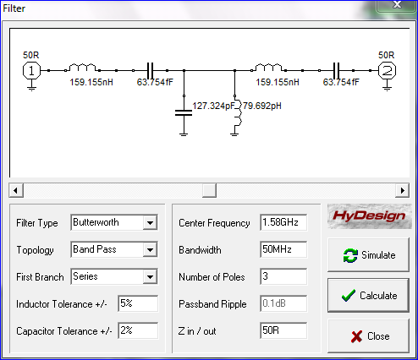
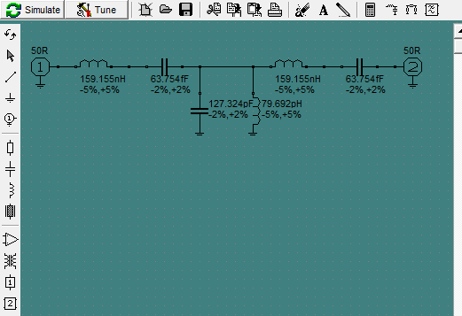
Figure 3-1 BPF1 bandpass filter design

3.1.3 Mixer
The function of the mixer is to multiply the RF signal with the local oscillator; VCO signal, by doing so the high frequency of the RF signal is down-converted and now manageable for signal processing. The output down-converted component is$A1A2/2[\cos\left(α-β\right)t]$ [12]

$A1$cos(αt) $Vo=A1A2/2\{$cos(α-β)t+cos(α+β)t}
$A2$cos(βt)
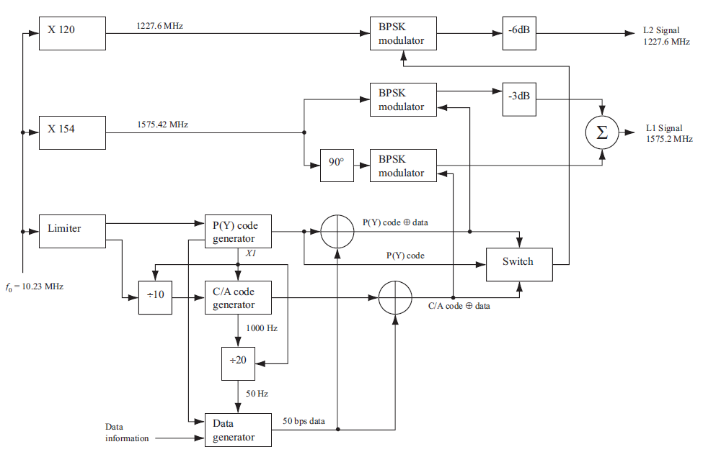Figure 3-2 satellite block diagram [9]
The signal from one satellite call k is of the form:-
$s^{k}\left(t\right)=\sqrt{2Pc } \left(C^{k}\left(t\right)⨁D^{k}\left(t\right)\right)\cos\left(2πfL1t+α\right)+\sqrt{2PpL1} \left(P^{k}\left(t\right)⨁D^{k}\left(t\right)\right)\sin\left(2πfL1t+α\right)+\sqrt{2PpL2} \left(P^{k}\left(t\right)⨁D^{k}\left(t\right)\right)sin⁡(2πfL2t+α)$---------------------------------------------3.1

Where $\sqrt{2Pc}$,$\sqrt{2P}pL1$,$\sqrt{2P}pL2$-power in signal with C/A or P code
${ C}^{k}-$ is the C/A code
$$p^{k}-is the P\left(Y\right)code$$
${ D}^{k}-$is the navigation data
α- carrier phase offset
The component with L1 is the one for civilian and L2 is for the American military purpose. The first component of L1 is the one multiplied with signal of $A2cos⁡(2π1.53*{10}^{9}t)$ from the oscillator. The amplitude $A2$ is determined by the integrated circuit. For this case the mixer the multiplied components are;

$\sqrt{2P} \left(C⨁D\right)cos⁡($2π1.57542*10^9)t * $A2cos⁡(2π1.53*{10}^{9}t)$
=$\frac{[A2\sqrt{2P} \left(C⨁D\right)]}{2}[\cos\left(2π45.42*{10}^{6}\right)t+\cos\left(2π3.1*{10}^{9}\right)t]$

The mixer is designed by ADL5357 integrated circuit by analogue devices, it has RF frequency range of 500—1700MHz and IF range of 30—450MHz.usiful information obtained from the datasheet, that is peripherals components connection is in appendix B.

3.1.4 Voltage Controlled Oscillator (VCO)
The VCO used was of frequency 1.530 GHz; cosine wave signal form, its signal is multiplied by incoming RF signal of 1.57542 GHz, to produce a down converted frequency; intermediate frequency of 45.42 MHz. The values of voltage controlling inductor and capacitor; external parallel tank are calculated bellow. $fo=1/2πLC$ Where L-inductor value C-capacitor value fo = 1.53 GHz; frequency of interest L=1.08nH C=0.01nF. The tank circuit is connected in parallel on pin 8 and 1with 8-positive. The VCO is designed by integrated circuit M100EL1648 8-pin. The AGC terminal is connected pulled down via 0.1micro Farads. Integrated circuit diagram with pin connection description is at appendix C. [12]
3.1.5 Intermediate frequency filter (IF BPF2)
The expected output frequency from the mixer is 45.42 MHz, leading to a bandpass filter of center frequency 45.42 MHz with reasonably chosen bandwidth of 20 MHz. This filter is to enable removal of the up-converted component of high frequency. The filter was designed by RFsim99 software. The following diagrams shows circuit generated after entering center frequency and bandwidth values.
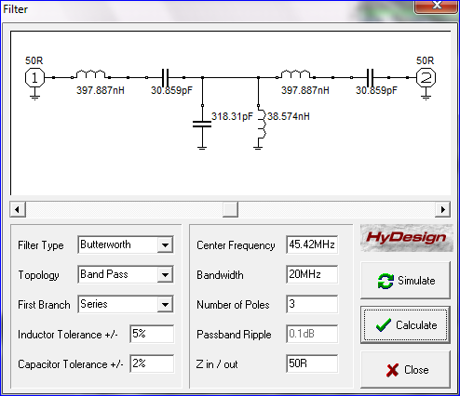
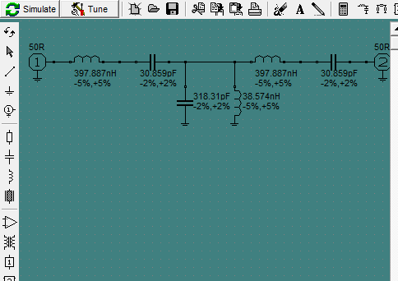
Figure 3-3 intermediate filter IF BPF2
3.1.6 IF Amplifier
The signal coming from the first IF filter is strengthened by amplifying it integrated circuit ADL5530 offers fixed gain of 16.5db which is reasonable, with noise figure of 3 db. Operates with frequency of up to 1000MHz. Valuable information is at appendix D. [12]
3.1.7 Intermediate frequency filter (IF BPF3)
After amplification the frequency of interest is still 45.42MHz leading to narrow bandpass filter of center frequency 45.42MHz; bandwidth of 6MHz, after this point 45.42MHz and the very nearest components of frequency are present. The design of the filter was designed by RFsim99 software by just specifying the center frequency and the narrow bandwidth of 6MHz.with simulation in chapter 4 the circuit diagram was :-
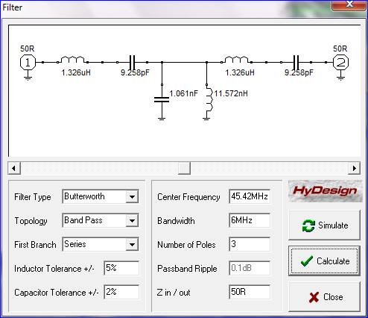
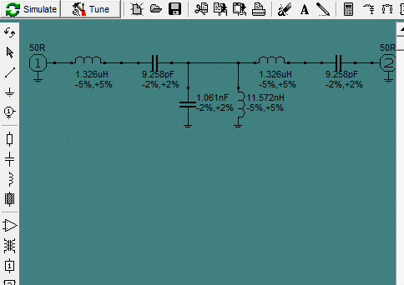
Figure 3-4 narrow filter IF BPF3
3.1.8 Analogue to digital converter (ADC)
Analogue to digital converter (ADC) converts intermediate frequency analogue signal to digital form to be processed by personal computer. Accurate knowledge of the sampling frequency is fundamental for high sensitivity and accuracy receiver signal processing. There are two ways of determining sampling rate of ADC; one is based on the center frequency obeying Nyquist sampling and the other is based on the information bandwidth or intentional aliasing. I preferred the second to first one since the navigation data is of interest. With respect to the current dual core processors in Pentium IV computers the digitized IF is expected to be in range of 6-10 MHz. Choosing 7 MHz for 8 bit samples the sampling frequency$(fs)$ is 56 MHz. The digitized IF signal is of the form:-
$S\left(nTs\right)= [ A2\sqrt{2P} ]/2\{D\left[nTs\left(1+γcd\right)-τ\right]*C\left[nTs\left(1+γcd\right)- τ\right]\cos{[\left(2π\left(fIf+ fd\right)nTs+ϕ\right]}\}$
Where;
$τ$—is the group delay
fd-- is the carrier Doppler shift
$γcd-$ is the relative code Doppler
$ϕ-$ is the carrier phase shift.
$γd-$ is the relative carrier Doppler
fIf – is the digitized IF frequency.
Ts – is the sampling period.
The relationship between the sampling frequency fs, analogue IFfaif and digitized IF fIf is;

fIf= |faif-(q/2)fs|
where q is an integer since fIf is 7 MHz, fs is 56MHz and faif is 45.42MHz. q is 1.357. An 8 bit output ADC0804 analogue to digital converter integrated circuit was
chosen and more details in appendix E.
3.1.9 Parallel to serial port2 converter
Parallel to serial convert is both transistor to transistor logic (TTL) and RS level. Converts 6 bit parallel ADC output into personal computer RS serial fomrt. Pins 2-9 of the parallel port are the ones used to input data into the converter. Pins 18-25 are ground pins. [17]
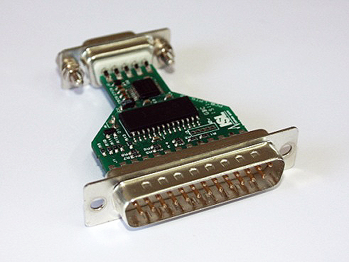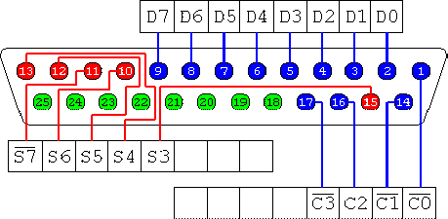
Figure 3-5 parallel to serial converter. [13]
3.2 Satellite Model
Referring to figure 3-2 the GPS satellite generates various components coupled together to form the GPS transmitted signal namely:-
- C/A or (PRN) code.
- Navigation data.
- Carrier wave both cosine and sine; L1- 1.57542 GHz L2- 1.227GHz.
- Precision or P(Y) code.
The modeling of the satellite model was done in matlab/Simulink software which offered friendly use and I had basics at hand.
3.2.1 Navigation data
The navigation data take the bipolar non return zero form that is digital signal alternating between -1and 1. It is modulo 2 selected with either P(Y) code or C/A code then modulates the carrier at 50 bits per second. The basic format of the navigation data is a 1500 bit long frame containing 5 sub-frames, each having length 300 bits. In Simulink the bipolar signal generator I used was OVSF code generator.
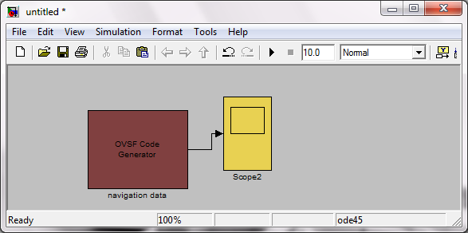
Figure 3-5 navigation data generator
The results displayed on the oscilloscope are in chapter 4.
3.2.2 Carrier wave
The GPS carriers are of frequency 1.57542 GHz and 1.227 GHz , however for the sake of simulation since i did not necessarily have to down-convert the signal from the satellite models, instead the digitized intermediate frequency 7 MHz was used for the carrier signal simulation. To generate the signal the voltage controlled oscillator(VCO) with quiescent frequency set to 7MHz together with offset phase angle 0.02 radians, to model real-time delay caused by ionosphere, troposphere and atmosphere effects of the transmitted GPS signal. Models of the Simulink software was used.
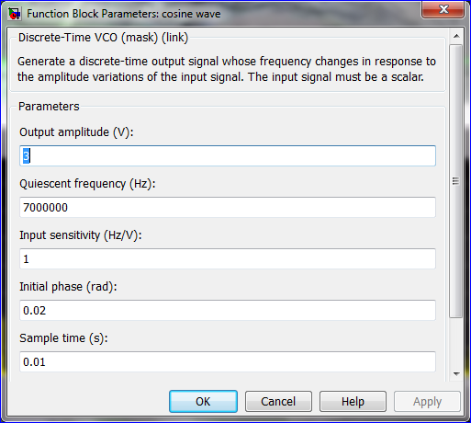
Figure 3-6 carrier frequency with offset phase setting.
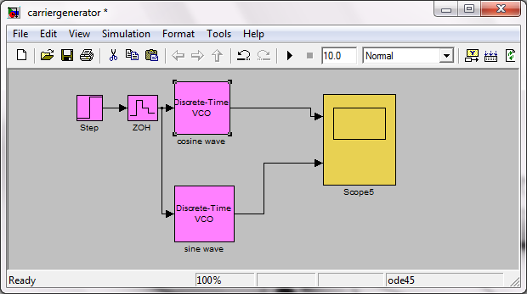
Figure 3-7 model generating both sine and cosine wave
The oscilloscope display results are in the fourth chapter.
3.2.3 C/A or Pseudo-random noise code
The PRN code generator is made of two 10 bit Linear feedback shift registers (LFSR), the next figure refers to them as G1 and G2 generators the polynomial for the G1 is $1+X^{3}+X^{10}$ and G2 $1+X^{2}+X^{3}+X^{6}+X^{8}+X^{9}+X^{10}$
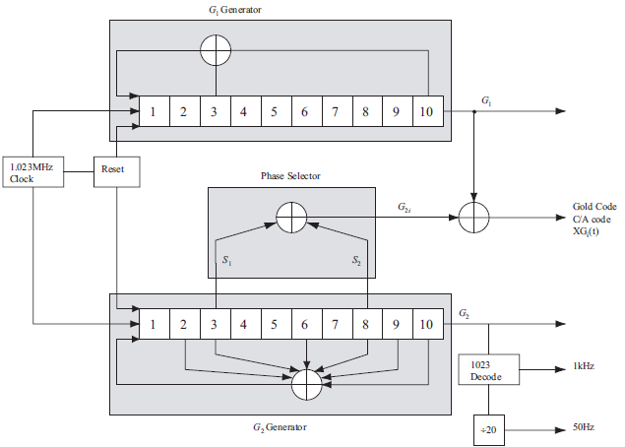[19]
Figure 3-8 satellite PRN code generator.
The modulo 2 addition is performed as shown in the figure above to generate the required maximum of 1023 series of binary chips code. To generate different unique PRN code for total 32 GPS satellite; code division multiplexing access (CDMA), the phase selector modulo 2 addition inputs are selected as in the following table.
[19]
Table 3-1 inputs selection for phase selector.
The ten bits of each register were modeled with ten unity delay functions, the modulo 2 addition was implemented by an XOR logical gate. Satellite number 08 was randomly chosen with phase selection inputs of 2 and 9. The signal generated was saved to the workspace to be used in the necessary stages. The model to implement the generator is as follow with oscilloscope results in the fourth chapter.
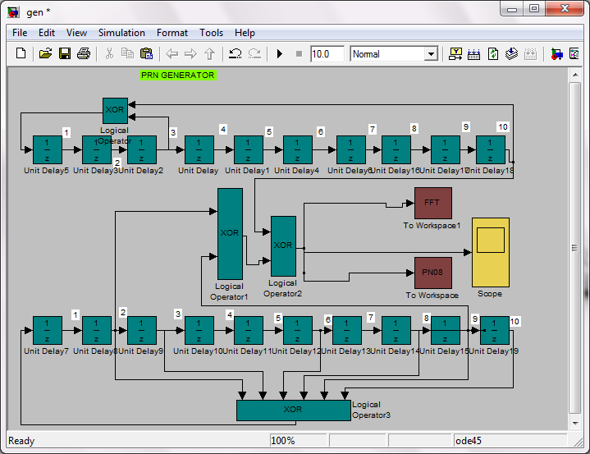
Figure 3-8 PRN generator for satellite 08.
3.2.4 Precision code.
The precision code is of the bipolar form alternating between -1 and 1, of frequency 10.23 MHz OSVF generator was used for code generation. Looking at equation 3.1 the first component which is civilian does not have the P(Y) code hence it can be omitted in the simulation. The precision code is used by the American department of defense and authorized government agencies.
3.2.5 Satellite components all together
By having modulo 2 addition of navigation data and the PRN code it is said to be Direct sequence spreading spectrum (DSSS). [14] The binary result was used to modulate the cosine carrier by Binary phase shift keying (BPSK). Simple BPSK modulation is the process of shifting a carrier’s phase by 180° for one data symbol while not shifting it for the other known as ‘antipodal’ phase shift modulation. The second component of the transmitted signal was generated by; modulo 2 addition of navigation data and precision code, then the result was used to modulate the sine wave. Between the satellite and the receiver channel there is ionosphere, troposphere and atmosphere which introduce noise to the signal of interest. To model these A White Gaussian Noise (AWGN) channel was used to add noise to the signal generated by the model. Modulated signals are displayed in the fourth chapter.
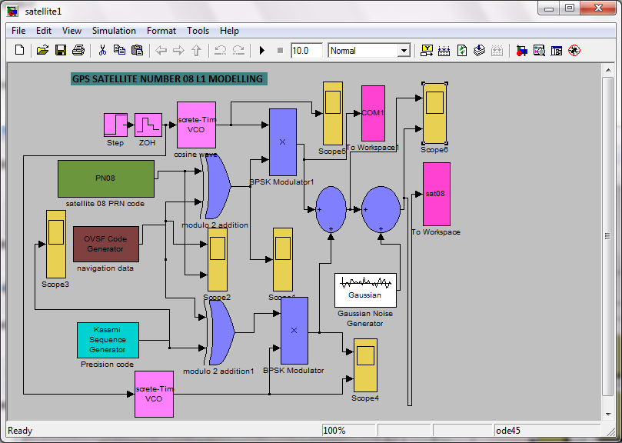
Figure 3-9 GPS satellite 08 model for the L1 signal
3.3 Software receiver
After RF front end, the receiver is made up of acquisition, tracking and satellite position calculation stages.

3.3.1 Acquisition
The signal acquisition process consists of a three dimensional search in time (code phase), frequency and satellite specific PRN code, in order to carry out demodulation of the GPS L1 signal.
The Fast Fourier Transform (FFT) or Parallel search method was selected because it is fastest of other methods like serial search. In FFT transform is based on conversion of sequence of data X(n) of length N into sequence X(K) of length N.
X(k)=$\sum_{n=0}^{N-1}{x\left(n\right)e^{-j2π/N} }$ 0<k<N-1
x(n)= $\sum_{k=0}^{N-1}{x\left(k\right)e^{j2π/N} }$ [20]
Computation of X(k) involves N complex multiplications and N-1 complex additions.
In this method 5000 samples of the received data are correlated with the code by circularly shifting replica code. The incoming signal is mixed with local carrier replica and the in-phase and the quadrature components are used as the real and imaginary inputs when calculating FFT. The incoming signal to the acquisition stage can be expressed as follows assuming Doppler shift for simulation case.
$$S\left(nTs\right)= \frac{[ A2\sqrt{2P} ]}{2}\{D\left[nTs\right]*C\left[nTs\right]\cos{[\left(2π\left(fIf\right)nTs+ϕ\right]}\}$$
Mixing with local cosine function;
$3\cos{[\left(2π\left(7.0*{10}^{6}\right)t\right]}$*$\frac{[ A2\sqrt{2P} ]}{2}\{D\left[nTs\right]*C\left[nTs\right]\cos{[\left(2π\left(7.0*{10}^{6}\right)nTs+5\right]}\}$
=$\frac{3[ A2\sqrt{2P} ]}{4}D\left[nTs\right]*\left[nTs\right]\{\cos{[\left(2π\left(\left(7.0*{10}^{6}\right)nTs+5\right)-\left(7.0*{10}^{6}\right)t\right]+}\cos{[\left(2π\left(\left(7.0*{10}^{6}\right)nTs+5\right)+\left(7.0*{10}^{6}\right)t\right]}\}$
Mixing with sine component;
$3\sin{[\left(2π\left(7.0*{10}^{6}\right)t\right]}$*$\frac{[ A2\sqrt{2P} ]}{2}\{D\left[nTs\right]*C\left[nTs\right]\cos{[\left(2π\left(7.0*{10}^{6}\right)nTs+5\right]}\}$
=$\frac{3[ A2\sqrt{2P} ]}{4}D\left[nTs\right]*C\left[nTs\right]\{\sin{[\left(2π\left(\left(7.0*{10}^{6}\right)nTs+5\right)-\left(7.0*{10}^{6}\right)t\right]+}\sin{[\left(2π\left(\left(7.0*{10}^{6}\right)nTs+5\right)+\left(7.0*{10}^{6}\right)t\right]}\}$
The second component of each product is filtered by a lowpass filter in my implementation frequency of 20Hz gave the best results. [23]The result is multiplied by complex conjugate of the local C/A code the circular convolution is obtained by taking the magnitude of inverse Fast Fourier Transform IFFT as seen in next figure.
Figure 3-10 FFT/parallel search method.

[23]
No- next carrier
no
no
yes
no
yes
yes
yes
Figure 3-11 flow chart showing FFT search

In Simulink software the PRN code was imported from the workspace, where it was stored as, The carrier replica was generated the same way as it was in the satellite model but without 0.02 radians offset phase.
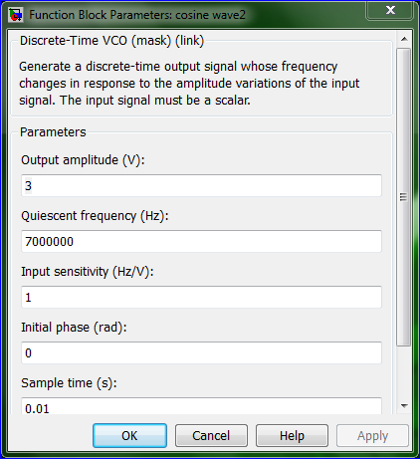
Figure 3-12 setting local carrier frequency without offset phase
The results of the next model are in the fourth chapter.
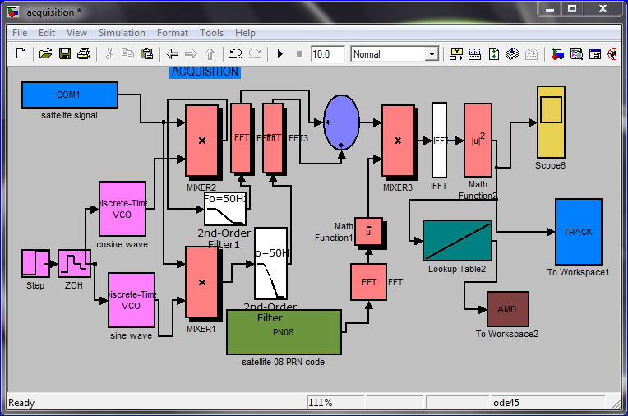
Figure 3-12 implementation of the FFT search for acquisition.
3.3.2 Tracking
After acquisition there is need to have a fine acquisition so that to have a pure navigation data. The PRN code and the carrier can be tracked. The carrier tracking loop tries to keep phase lock of the satellite as long as the frequency drift is within a given boundary. The acquisition will give the carrier frequency within +-500Hz, the carrier tracking must then first bring the carrier frequency into the lock. The carrier tracking was approached by Costas loop that is phase lock loop (PLL). The aim of the Costas loop is to try to keep all energy in the in-phase arm. In order to do this, some kind of feedback to the oscillator is needed. The intermediate frequency signal is first collapsed into the baseband in form of in-phase and quadrature components using the carrier frequency, the result is then multiplied by the replica code. [23] The signal is then fed to the Low pass filter to remove high frequency noise components. The navigation data is now obtain in the In-Phase arm, the quadrature component is divided by the in-phase component the arctangent of the result is carried out, this is done in the carrier discriminator block, then the output filtered by a discrete filter also called carrier loop filter, the filtered signal is used to drive the numerically controlled oscillator (NCO) whose signal is mixed with incoming signal to the tracking stage.The multiplication in the in-phase arm yields the following sum:-
Where $φ$ is the phase difference between the phase of the input signal and the phase of the local replica of the carrier phase. The multiplication in the quadrature arm gives the following:-
If the two signals are lowpass filtered after the multiplication, the two terms with the double intermediate frequency are eliminated and the following two signals remain:
To find a term to feed back to the carrier phase oscillator, it can be seen that the phase error of the local carrier phase replica can be found as
The carrier loop filter is a first order filter described by transfer function in Z- domain. [19]
F(z)=$\frac{\left(C1+C2\right)-C1*Z^{-1}}{1-Z^{-1}}$
Where C1= $\frac{1}{k}$ $\frac{8 Ϛw⍙T}{4+4Ϛw⍙T+{\left(w⍙T\right)}^{2}}$
C2= $\frac{1}{k}$ $\frac{4{\left(w⍙T\right)}^{2}}{4+4Ϛw⍙T+{\left(w⍙T\right)}^{2}}$
$w$=$\frac{2B}{Ϛ+\frac{1}{4Ϛ}}$
$⍙T=\frac{1}{1000}$
$Ϛ-damping factor$
$B$,$Ϛ, k$variables are varied to have a quality filter response.
Navigation data tapped here
Figure 3-13 Costas loop used for signal tracking.
In my design the above variables were varied, but the response of the carrier loop filter was not the desired one, the Costas loop was then replaced with no feedback, since the function of the feedback is to keep the energy concentration in the in-phase arm and not the quadrature arm.

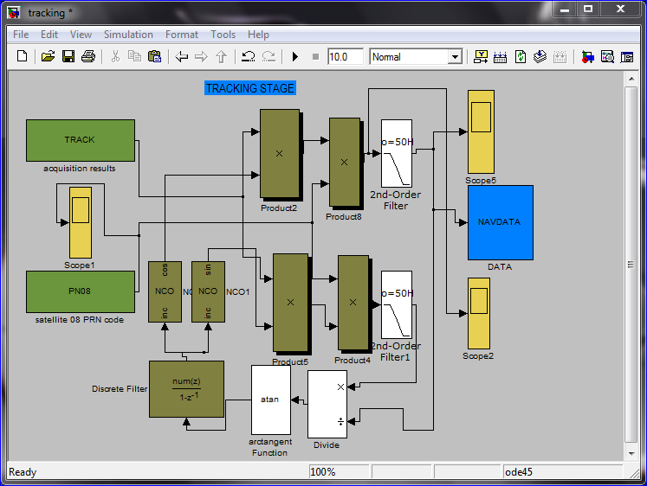
Figure 3-14 Simulink Costas loop tracking implementation
After simulation i designed real time signal processing model, the model gets the signal from the serial port which has been digitized by the ADC, then fed into acquisition stage for signal processing.
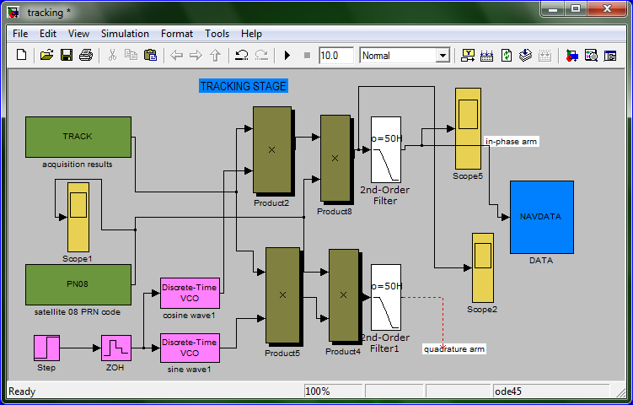
Figure 3-15 Costas loop without feedback
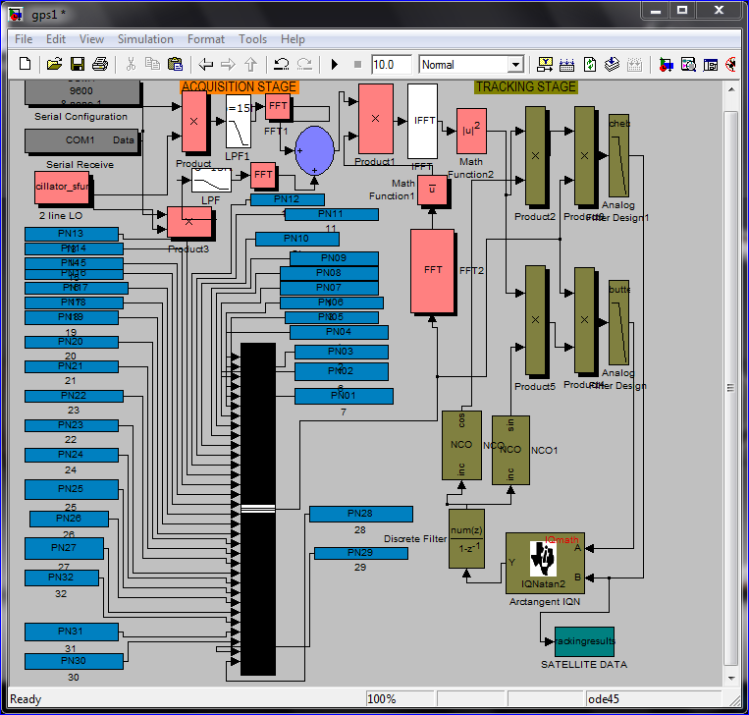
Figure 3-15 Simulink model configured to process real time signal processing for both acquisition and tracking stages.

CHAPTER 4
RESULTS –SIMULATION
4.1 RF front end
4.1.1 RF Bandpass filter (RF BPF1)
Simulation of the center frequency 1.57542 GHz and bandwidth of 50MHz bandpass filter was as bellow. Only components in the neighboring of +_ 25 MHz of 1.57542GHz are allowed to pass.
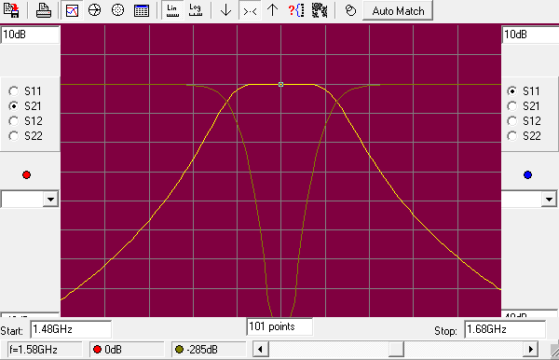 Figure 4-1 plot of RF-BPF1 filter
4.1.2 Intermediate frequency filter (IF BPF2)
Simulation of the center frequency 45.42MHz and bandwidth of 20MHz bandpass filter was as bellow. Only components of in the neighborhood of +_ 10MHz of 45.42 MHz are allowed to pass.
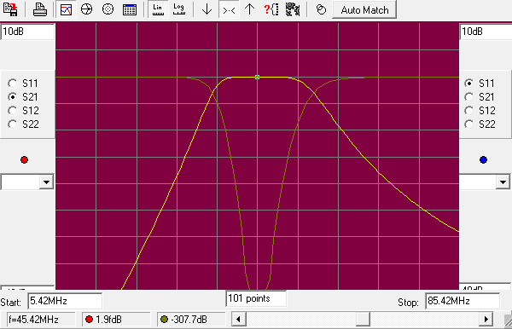
Figure 4-2 graphical plot for IF BPF2

4.1.3 Intermediate frequency filter (IF BPF3)
Simulation of the center frequency 45.42MHz and narrow bandwidth of 6MHz bandpass filter was as bellow. Only components of in the neighborhood of +_ 3MHz of 45.42 MHz are allowed to pass.

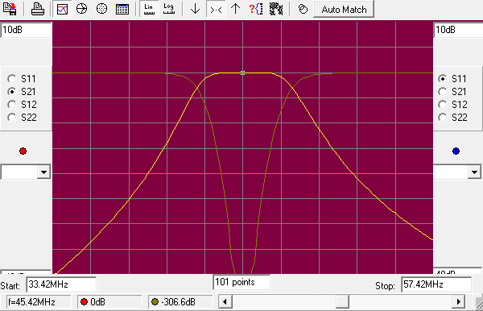
Figure 4-3 narrow bandpass BPF3 plot.
4.2 Satellite Model
4.2.1 Navigation data results
Results displayed on the oscilloscope after generating navigation data, a signal of bipolar form was as follows:-
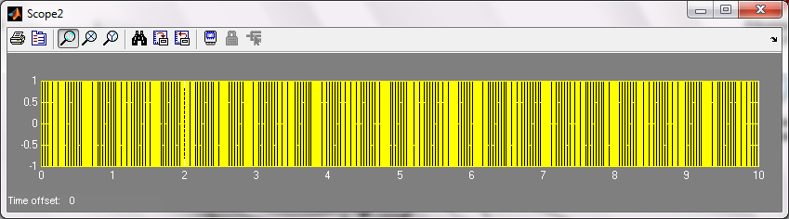
Figure 4-4 navigation data simulation.
4.2.2 Carrier signals
Results displayed on the oscilloscope after generating carrier waves was as seen in the next figure. The 1was used as my starting point and not zero:-
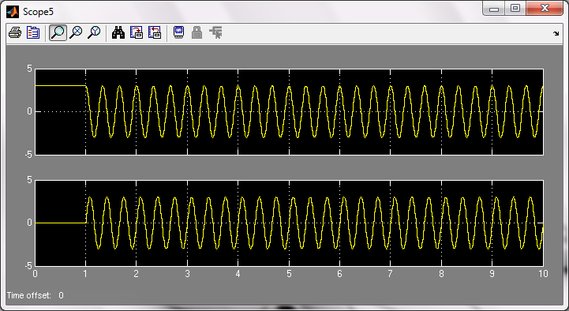
Figure 4-5 carrier wave simulation
4.2.3 C/A code
A pseudo-random noise of 1024 binary form chips was generated, the generated code displayed on the oscilloscope and results captured by windows application snipping software as:-
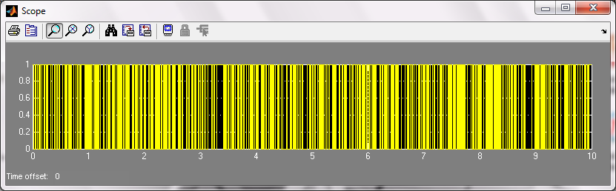
Figure 4-6 C/A code results for GPS satellite 08
The modulo 2 addition of C/A and navigation data is expected t result in binary format which was displayed as follows.
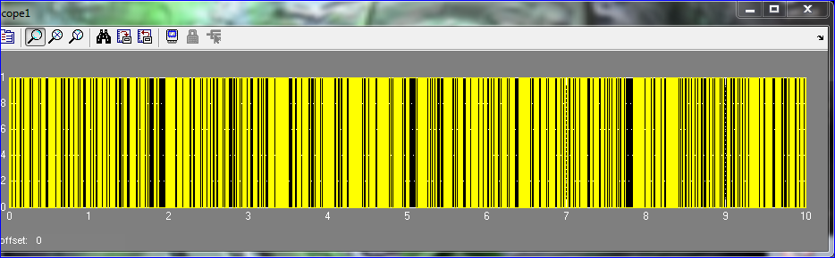
Figure 4.2.4 Modulo 2 addition of the C/A and navigation data results
4.2.4 Satellite components all together
The carrier is shifted 180 degrees for +1 and 0 degree for 0, the modulated carrier signal is displayed next.
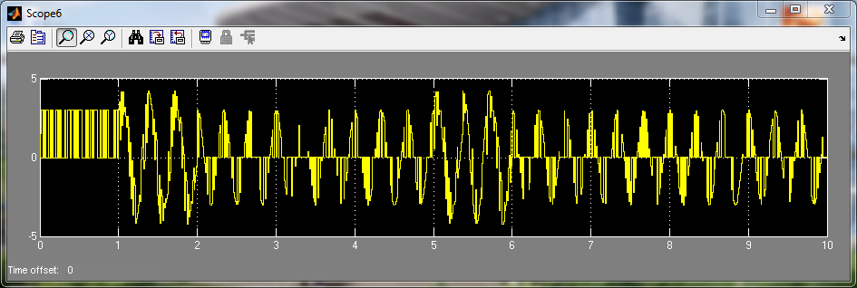
Figure 4-7 modulated L1 signal.
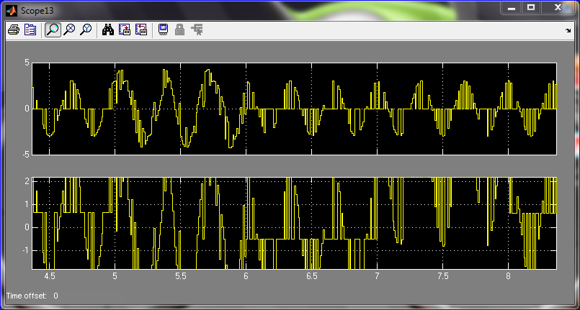
Figure 4-8 signal 1 showing modulated L1 zoomed in from 4.5 to 8.5 seconds
The modulated signal after addition of noise the signal the signal changes in shape as follows.
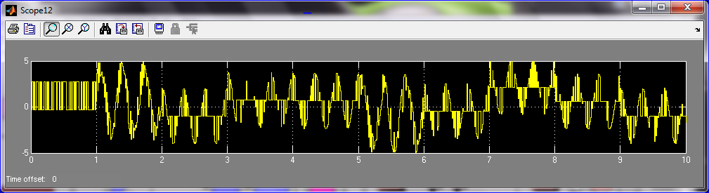
Figure 4-9 modulated L1 signal after addition of noise
Zooming in at instance is necessary since my carrier was beginning at 1 and not zero, by that the zoomed results were as follows.
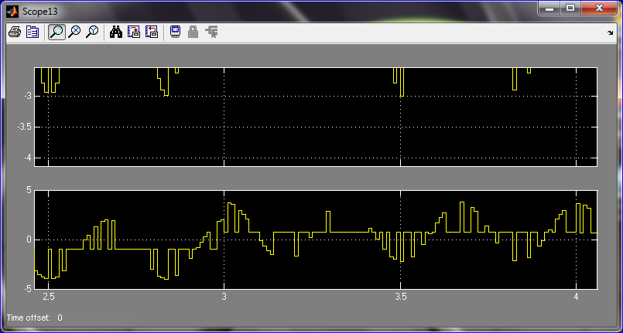
Figure 4-10 Signal 2 showing noisy L1 zoomed in from 2.5 to 4 seconds
4.3 Software receiver
4.3.1 Acquisition
The display results on the oscilloscope were capture as bellow showing correlation peak, just as expected.
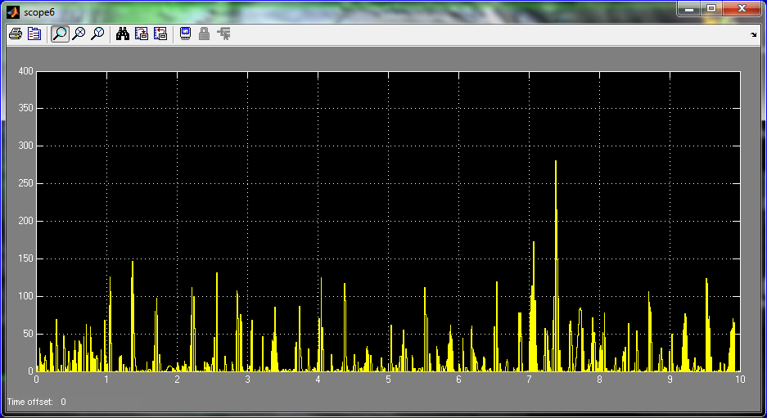
Figure 4-11 Acquisition-correlation peak results for satellite 08.
4.3.2 Tracking
The demodulated signal obtained was found to contain small amount of noise, this tresses of noise is the Gaussian noise I included in the Gaussian block. Since the block did not specify frequency the trial value for lowpass filter was 15 Hz. The tracking results of the Costas loop without the feedback part was as bellow
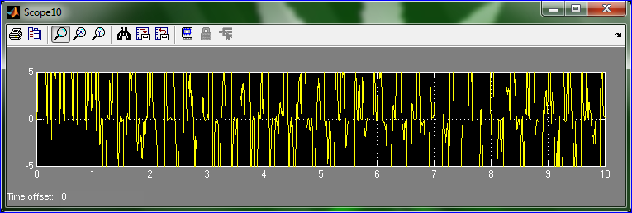
Figure 4-12 tracking results-navigation data extraction with small amount of noise

CHAPTER 5
CONCLUSION AND RECOMMENDATION
The study of GPS system together with SDR, design and demonstration of the SDR has been completed as required by the problem statement and scope limit. The complete RF front end was design.
5.1 RF Front end
The IF amplifier together with narrow bandpass filter can also be replaced with Automatic Gain Control (AGC), which can control the overall gain of the different stages of the RF Front end, by implementing a feedback.

IF amplifier

IF BPF3

First IF filter ADC

Figure 5-1 IF amplifiers with narrow bandpass filter.
Figure 5-2 AGC block diagram.
The AGC is made up of Variable Gain Amplifier (VGA), the detector then the integrator that integrates the error and feed it back to the VGA. This topology is to make sure that the gain variation does not go out of control.
5.2 Acquisition
Signal processing books offer the implementation of the parallel /FFT search method for the acquisition of signals, however implementation of the GPS software radio Receiver.[23] A lowpass filter has to be placed between the carrier mixer and the FFT blocks to ensure removal of the up-converted component after multiplication with the incoming signal shown in the next mathematical expression.
For in-phase arm.
$3\cos{[\left(2π\left(7.0*{10}^{6}\right)t\right]}$*$\frac{[ A2\sqrt{2P} ]}{2}\{D\left[nTs\right]*C\left[nTs\right]\cos{[\left(2π\left(7.0*{10}^{6}\right)nTs+5\right]}\}$
=$\frac{3[ A2\sqrt{2P} ]}{4}D\left[nTs\right]*\left[nTs\right]\{\cos{[\left(2π\left(\left(7.0*{10}^{6}\right)nTs+5\right)-\left(7.0*{10}^{6}\right)t\right]+}\cos{[\left(2π\left(\left(7.0*{10}^{6}\right)nTs+5\right)+\left(7.0*{10}^{6}\right)t\right]}\}$
Mixing with sine component/quadrature arm.
$3\sin{[\left(2π\left(7.0*{10}^{6}\right)t\right]}$*$\frac{[ A2\sqrt{2P} ]}{2}\{D\left[nTs\right]*C\left[nTs\right]\cos{[\left(2π\left(7.0*{10}^{6}\right)nTs+5\right]}\}$
=$\frac{3[ A2\sqrt{2P} ]}{4}D\left[nTs\right]*C\left[nTs\right]\{\sin{[\left(2π\left(\left(7.0*{10}^{6}\right)nTs+5\right)-\left(7.0*{10}^{6}\right)t\right]+}\sin{[\left(2π\left(\left(7.0*{10}^{6}\right)nTs+5\right)+\left(7.0*{10}^{6}\right)t\right]}$}
In the two products the component with angle summation which is up-converted are the ones to be filtered out by the lowpass filter. For this case the filter was set to 20Hz cut off frequency.
Figure 5-3 FFT search as offered on signal processing books.
Figure 5-4 FFT search with lowpass filters
5.3 Matlab/Simulink
The Simulink software i used for my simulation offers one of the best environment for signal processing, however the Matlab/Simulink do have software failures. When a signal sample has been stored in the workspace sometimes when imported can have distortion. For this project i had to simulate the complete GPS satellite model, acquisition and tracking models in one model to have desired results. The discrete filter in my Costas loop that is supposed to implement carrier loop filter, did not work as expected.
Appendix A [12,13]
Pin Number | Description
1 | Internal DC bias
2 | RF input
3,4,5,6 | No connection
7 | RF output
8 | Supply (VDD +5V)
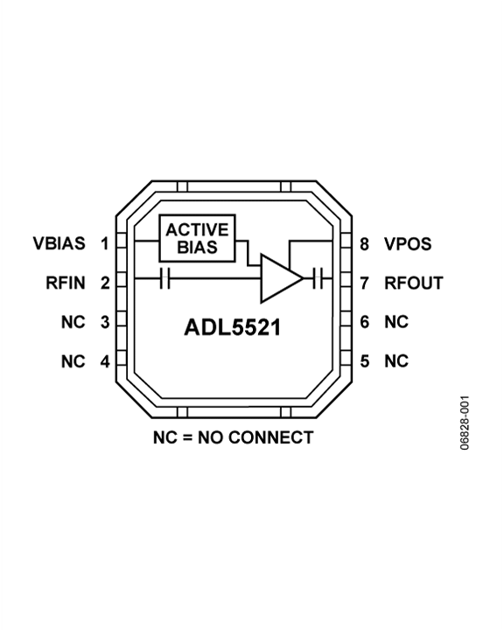 | Diagram showing the integrated circuit  Gain of 15.3dB maximum 1950MHz  Matched 50-Ω input and output  Noise Figure of 0.8dB at 1950MHz  Single 5V Supply Operation  Operating current of 65mA at +5V  LFCSP 3x3 mm Package
Parameters | value
Noise figure | 0.8 db
Gain | 15.3db

Appendix B
Pin Number | Description
1 | Positive supply voltage for IF amplifier
2 | RF input
3 | RF balun center tap
4,5 | DC ground
6,8 | Positive supply voltage for LO amplifier
7 | LO Amplifier bias control
9 | LO switch
10 | No connection
11,15 | LO inputs
12,13 | Ground
14 | Positive supply for LO switch
16 | Ground
17 | Ground
18,19 | Differential IF outputs
20 | IF Amplifier bias control
Parameter | Condition
RF frequency range | 500—1700MHz
RF input impedance | 50Ώ
IF range | 30—450 MHz
DC bias voltage | 5.0 V
LO frequency range | 730—1670MHz

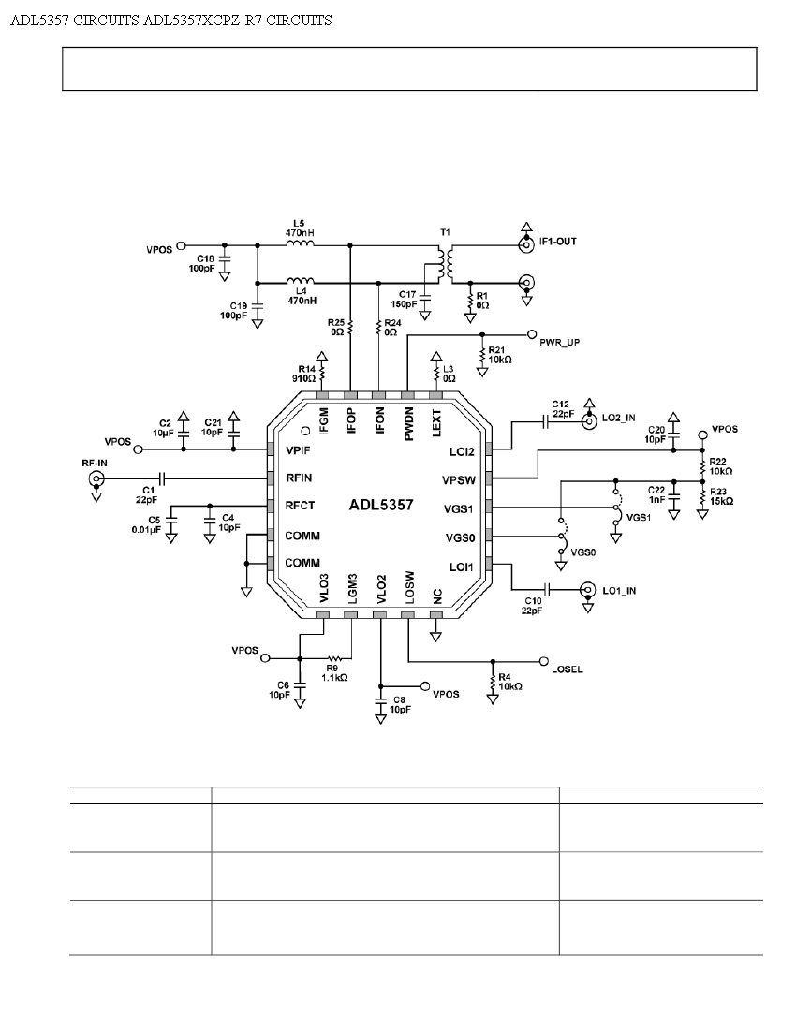
Figure B-1 ADL 5357 connection [12,13]

Appendix C
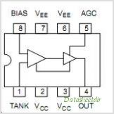 [12,13]
Figure C- 1 M100EL1648 diagram to achieve 1.53Ghz
Pin Number | Description
1 | Oscillator input voltage
2,3 | Vcc positive supply coupled by 0.1µF capacitor
4 | ECL output
5 | Automatic gain control input
6,7 | Negative output
8 | Oscillator input reference voltage

Appendix D
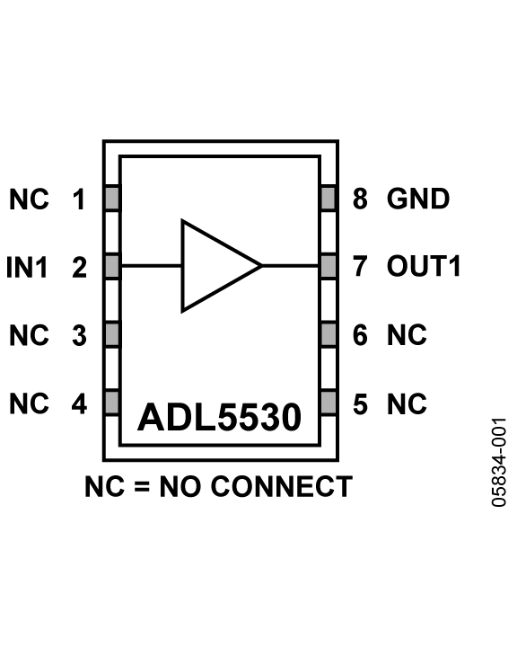[13] [12]
Figure D-1 ADL5530 diagram.
Pin Number | Description
1,3,4,5,6 | No connection
2 | Input caupled with capacitor C-10nF
7 | Output coupled with capacitor c-10nF supply 5V caupled with tank circuit of L-470nH, C-10nF.
8 | ground

APPENDIX E
ADC chosen [13]
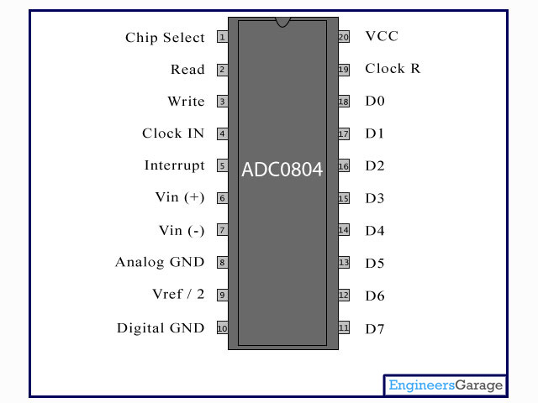
Figure E-1 ADC diagram
APPENDIX F
Acronyms
ADC- Analogue to Digital Converter
AGC- Automatic Gain Control
ASIC – Application Specific Integrated Circuit
AWGN- A White Gaussian Noise
BOC- Binary Offset Carrier
BPF- Bandpass Filter
BPSK- Binary Phase Shift Keying
CDMA- Code Division Multiplexing Access
C/A - Acquisition Code
DSSS- Direct Sequence Spreading Spectrum
ELV- Expandable Launch Vehicle
ESA- European Space Agency
EC- European Commission
FPGA- Field Programmable Gate Array
FDMA- Frequency Division Multiplexing Access
FFT- Fast Fourier Transform
GPS- Global Positioning System
GNSS- global Navigation Satellite System
GLONASS-Global Orbiting Navigation Satellite System
GEO- Geostationary Orbit
HOW- Hand Over word
I In-Phase Arm
IF- Intermediate Frequency
IFFT- Inverse Fast Fourier Transform
LNA- Low Noise Amplifier
LPF- LowPass Filter
LO- Local Oscillator
NAVISTAR-GPS- Navigation System with Timing And Ranging Positioning System
NMEA-National Marine Electronics Association
NEI- Nederland Economic Institute
NCO- Numerically Controlled Oscillator
OCS- Operation Control System
PRN- Pseudo-Random Noise
P(Y)- Precision Code
PLL- Phase Locked Loop
Q- Quadrature Arm
RF- Radio Frequency
SDR- Software Define Radio
SPS- Standard Position Service
TTL- Transistor Transistor Logic
UTC- Universal Time Co-ordinate
VCO- Voltage controlled Oscillator
ZOH- Zero Order Hold
Bibliography
[1]- Behzad Razavi; University Of California “RF Microelectronics” , July 1998.
[2]- http://www.Wikipedia.com November 2011-2012
[3]- http://www.Alldatasheetarchive.com November 2011-2012
[4]- T.J. Martín Mur & J.M. Dow; Orbit Attitude, European Space Operations Centre
(ESOC); “Satellite Navigation Using GPS” 2000.
[5]- Heikki Hurskainen, Jussi Raasakka, Tapani Ahonen, and Jari Nurmi
“Multicore Software-Defined Radio Architecture for GNSS Receiver Signal
Processing” 2009.
[6]- Geoffrey Blewitt; Department of Geomatics, University of Newcastle Newcastle
upon Tyne, NE1 7RU, United Kingdom “Basics of the GPS Technique” 2004
[7]- Jean-Marie_Zogg; “GPS Basics” 2002.
[8]- Qiuting Huang, Senior Member, IEEE, Paolo Orsatti, and Francesco Piazza “GSM
Transceiver Front-End”
[9]- Akos, D.M. (1997). A Software Radio Approach to Global Navigation Satellite
System Receiver Design. PhD thesis, Ohio University.
[10]- Glen Gibbons, Jr “Journal of Global Positioning Systems” (2004)
[11]-Domine Leenarts, Cicero S.Vaucher-Philips Research Laboratories Eidhoven;
Johan Van Der Tang- Eidhhoven University of Technology “circuit Design
For RF Transceiver. 2001.
[12]-Analogue Devices, analogue.com/RF “RF IC selection Guide” 2012.
[13]-http://www.google.com/images november2011-2012.
[14]-Bud Robinson “Direct Sequence Spreading Spectrum” May 2001.
[15]-K. L. Harman Command, Control, Communications and Intelligence Division
Defence Science and Technology Organisation; “Direct Sequence Spreading
Spectrum” January 2008.
[16]- http://web.idirect.com/~warp “programming Parallel and Serial Ports”
2012.
[17]- www.lavalink.com “IEEE 1284: Parallel Ports” 2002 Lava Computer MFG Inc.
[18]- Saeid NooshabadiDept. of Information and CommunicationsGwangju Institute
of Science and TechnologyRepublic of Korea, “Design of a Costas Loop Down
Converter” 2006.
[19]- Fredrick Johnsson, Rahman Mollaei, Jonas Thor, “GPS Satellite signal Acquisitio
And Tracking” August 1998.
[20]-C. Kankelborg “DFT and FFT” January 2009.
[21]- Kai Borre Aalborg University Denmark ; “The Gallileo Signal” Lecture at SU
May 27, 2009.
[22]- Darius Plausinaitis Danish GPS Center “GPS Receiver Development”
[23]- K. Borre; Aalborg University, D. Akos University of Colorado; GPS and Gallileo
Receiver Single frequency approach. September 2005.
[24]- Gihan Gomah Hamza†, Abdelhaliem A. Zekry, and Mohamed N. Moustafa
“Journal of Global Positioning Systems” (2009).
[25]- Maryam Sadeghi, Majid Gholami Dept. of Electrical Engineering University of
Azad Eslamshahr branch “Time Synchronizing Signal by GPS Satellites” may
2008.
[26]- GPS technology: http://www.trimble.com/gps/ http://www-psg.mit.edu/
~tah/12.540/12.540.Lec06.pdf
[27]-http://www.matworks.com/Simulink November 2011-2012
[29]- Wikipedia (2010), ‘Linear Feedback Shift Register’
http://en.wikipedia.org/wiki/Linear_feedback_shift_register

